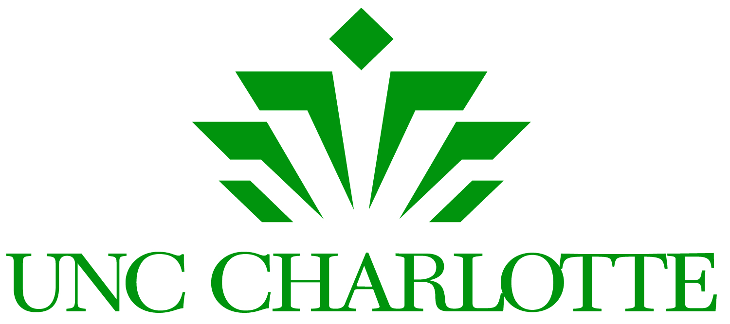

Founders Celebration
September 21-24, 2016

Time Capsule Presentation Ceremony
September 20 - 12:00 p.m.
Belk Plaza, UNC Charlotte
Celebrate with Chancellor Dubois and Student Body President Fahn Darkor as we preserve Niner Nation history with a commemorative time capsule. The time capsule will be buried in Belk Plaza and opened in 2046 on the University's 100th Anniversary.

Chancellor's Speaker Series
September 21 - 3:30 p.m.
Multipurpose Room, Student Union, UNC Charlotte
Join former Secretary of Defense and best-selling author Dr. Robert Gates for thought provoking conversation on leadership, politics, and the inner-workings of Washington.

Giving Green Kick Off
September 22 - 11:30 a.m.
Multipurpose Room, Student Union, UNC Charlotte
Kick off the annual campaign benefitting UNC Charlotte and the greater community.

An Exponential Celebration
September 22 - 12:15 p.m.
Student Union, UNC Charlotte
A celebration to mark the 70th anniversary of UNC Charlotte’s founding and kick off an even greater future.

49er Fest
September 22 - 4:30 – 7:30 p.m.
UNC Charlotte Center City Campus
Come together with UNC Charlotte Alumni and Friends for a celebration of 70 years of excellence in higher education.

#NinerNationGives
September 22-23
Build community, celebrate your 49er pride, and give back to the University.

International Festival
September 24 - 10:00 a.m. – 6:00 p.m.
Barnhardt Student Activity Center, UNC Charlotte Campus
The 41st year of a campus tradition, recognizing the region’s growing diversity.

